Game title:

Forgotten Paragons
(most of these things are subject to change)

This game design document consists of multiple pages and an extensive overview of each mechanic.
(or at least it eventually will)

TABLE OF CONTENTS
1.1 - The main page (You’re here!)
1.2 - Game Summary (Gameplay)
1.3 - Game Summary (Story)

2.1 - Planned Features and player overview
2.2 - Gameplay
2.3 - Gameplay : Wuxia
2.4 - Gameplay : Knight
2.5 - Gameplay : Onna-musha
2.6 - Player Perspective

3.1 - Graphics and Artstyle

4.1 - Levels

5.1 - Enemies

6.1 - Bosses

7.1 - Progression (In-game progression)
7.2 - Souls (Skill & Player XP) (And the skill tree)
7.3 - Unlockables
7.4 - Currency
7.5 - NPCs / Shops / Vendors and their relevance to progression

8.1 - Current Gamestate

9.1 - Story
9.2 - Setting

1.2 Summary Of The Game (Gameplay Wise)

Cross-breed between Sifu combat and Yakuza combat. Styles vary heavily between character classes, character fighting styles, and weapon choice.
(Some characters have multiple weapons with only one style, some characters have multiple weapons with multiple styles, one character uses 1 weapon with multiple styles)

Rogue-lite progression (wow how original)
Rogue-like + Beat Em Up gameplay. If you lose, you’re sent back to the hub to start again, no exceptions.
3D Brawler, think Yakuza and Sifu like mentioned before.
Money and item shop
Mid-run vendors to promote player agency (good balance of choices and RnG)

Yakuza Gameplay Image
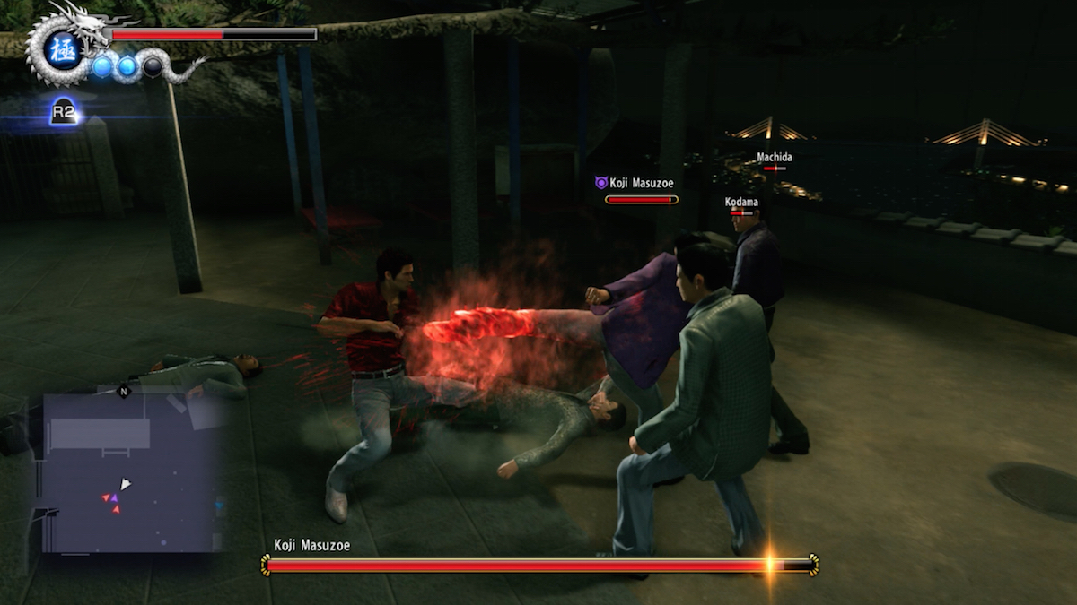
Sifu Gameplay Image
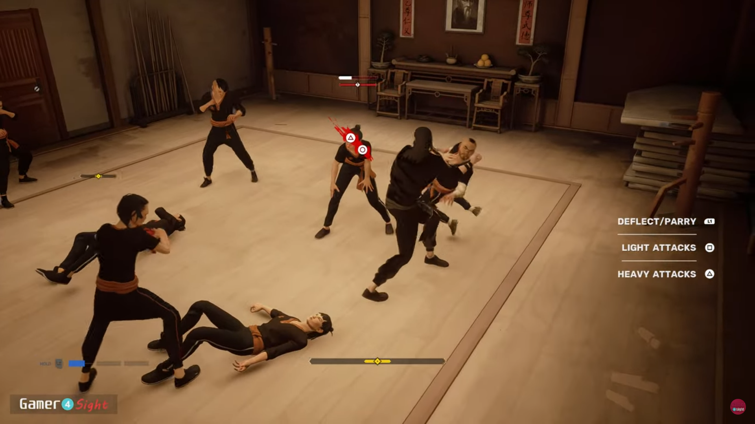
1.3 Story Summary
At the heart of the tower lies an unknown entity, a force conjured and twisted by the very fabric of the shadows themselves. This unknown and horrid thing has plagued the lives of all, not just those residing in their respective lands.

Ghosts, goblins, demons, yokai. These terrors have many names, but a more apt word has come forth; Monsters.

Monsters now terrorise the innocents because of the tower and this unknown evil needs to be put to rest.

Many have tried to dispel the evil. Masters and students of swordsmanship, martial arts and raw combat.

None have succeeded.

There were a notable four however.

Four legendary warriors, all united by a cause, despite all their differences in cultures.

A noble knight, who had sought to rid the evil in service of his people and his king.
A beautiful onna-musha (term for swordswoman in japanese, roughly), who had sought to rid the evil in service of her shogunate.
A vicious and boisterous, bear of a man, who had sought to rid the evil to bring glory to their clan.
A calm and collected martial arts master, who had sought to rid the evil to bring balance to the lands.

They all have fallen to the tower, and the sands of time were not kind to their stories either. For each of them have been mostly forgotten.
Their tenacity, however, is said to live on in the future heroes that have attempted the same deeds.

Perhaps these next four will be able to do what they could not, perhaps they may put all the lost souls in the tower to rest.

2.1 Planned Features
-Four playable characters. Knight, Samurai/Onna-musha, Viking and Wǔxiá (Meaning martial arts hero). (Priority is the Wuxia)
-Playable characters have different fighting styles and unique gameplay mechanics tied to them.
-First character to be implemented will be Wuxia.
-5 distinct bosses, I might add more later. Each of the bosses represent one of the warriors of legend, the first four representing the “legendary heroes” and how they’ve fallen from grace.

-5 Levels, but of course the method of progression in these levels are long, with tileset rooms being generated for them. Just like in Binding of Isaac/Enter The Gungeon/Deadlink etc.

-Maybe secret levels, not really a priority, but just putting it here just in case

-Passive items, potions and a shop.

-Passive items are the majority of items you’ll receive, potions behave similarly to how they do as active items in Enter The Gungeon, but they’re more frequent.

-Shop is pretty self explanatory, you buy items there, you buy potions there

-Enemies drop upgrade currency (souls) and cash for shop items

2.2 Gameplay
3D Lock-on combat.
- Health bar
- Stamina bar (allows players to block)
- Light attacks and heavy attacks
- All characters can block
- All characters can parry
- Animation cancelling
- Combos
- Variation in combat
- Knight and Onnamusha can choose to use different weapons, each with a unique moveset
- Viking use different weapons + different styles
- Wuxia uses ONLY different styles, solely hand-to-hand combat
- Unlockable/purchasable upgrades
- Items to help enhance the player’s capabilities (increasing adrenaline gain, etc. ofc these items have specific models and rarities as is customary with rogue-likes)
- Let’s try and aim for a small amount of 5 items at first.

2.3 Gameplay : Wǔxiá
Combat

As a martial arts master, the Wuxia of legend is capable of adapting to the situation at hand using their inherent knowledge and years of trained muscle-memory. Weapons may be good, but if a sword dulls and a shield breaks, then only your fists remain. Wuxia's greatest weapon, is one that never dulls and is always ready.

Too bad you’re not that legendary Wuxia lmao.

But eventually, YOUR Wuxia, will be.

Wǔxiá Specific
Hand To Hand Combat
So what does this mean? Well, given that you’re going to be punching opponents who have some form of armour, Wuxia’s attacks aren’t really that strong damage-wise, but they make up for it for the vast pool of attacks they always have on hand.

They solely use hand-to-hand combat, they cannot use any other weapons. This equipment can be bought from the Tower Forgemaster, an NPC that can be found throughout the tower

Combat Styles: Crane (Basic & Versatile) (based on Fujian White Crane)
The crane is a style that is versatile and adaptable, maintaining proper distance with well-placed strikes and decent damage. Attacks are never lightning fast nor extremely slow.
Balance is key, and this style delivers it masterfully.
Combat Styles: Rock (Hard Knocks and Hard Cocks) (Based on Bajiquan)

Combat Styles: Bak Mei (Sifu Moment) (Fast Style)
Bak Mei is another arm-focused martial art that is fast, precise and explosive.
This results in the legs being freed up for evasiveness and thus resulting in a style that accentuates fast, precise and strong strikes that can always be recovered from.

Attacks are never fully committed to, which allows the user to always evade and strike back when necessary.

Adrenaline Gauge
The rush of combat allows the Wuxia (and the viking) to increase in combat ferocity as the battle progresses.

Adrenaline is a resource that can be spent or maintained at the player’s discretion
- Adrenaline is gained by beating up enemies, evading strikes etc.
- Lost by taking damage
- Can be spent to execute “martial prowess” for the Wuxia
- Martial prowess is a special move that plays a specific animation that shows the player brutalising the enemy stylishly
- Okay yes, it’s a heat action.
- Higher adrenaline : Faster attacks

3.1 Graphics
(and stuff related to visuals)
It’s a 3D Game.

Similar to Sifu and Absolver. Stylised models, atmospheric and dark.

Colour scheme and general setting can be considered “Dark Fantasy” but with settings based
Painterly-style textures that look very story bookish.
Example images below
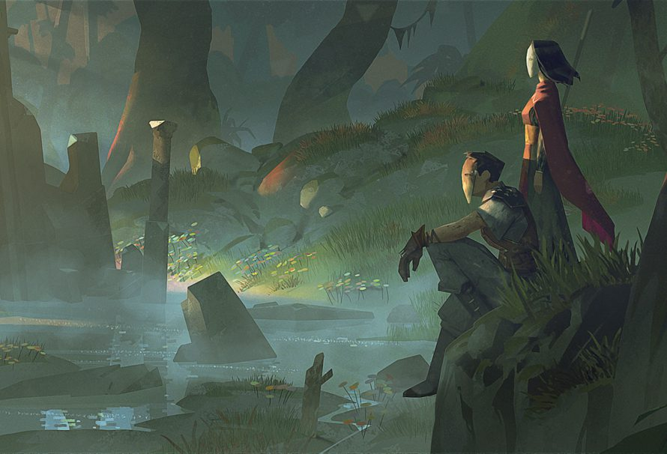
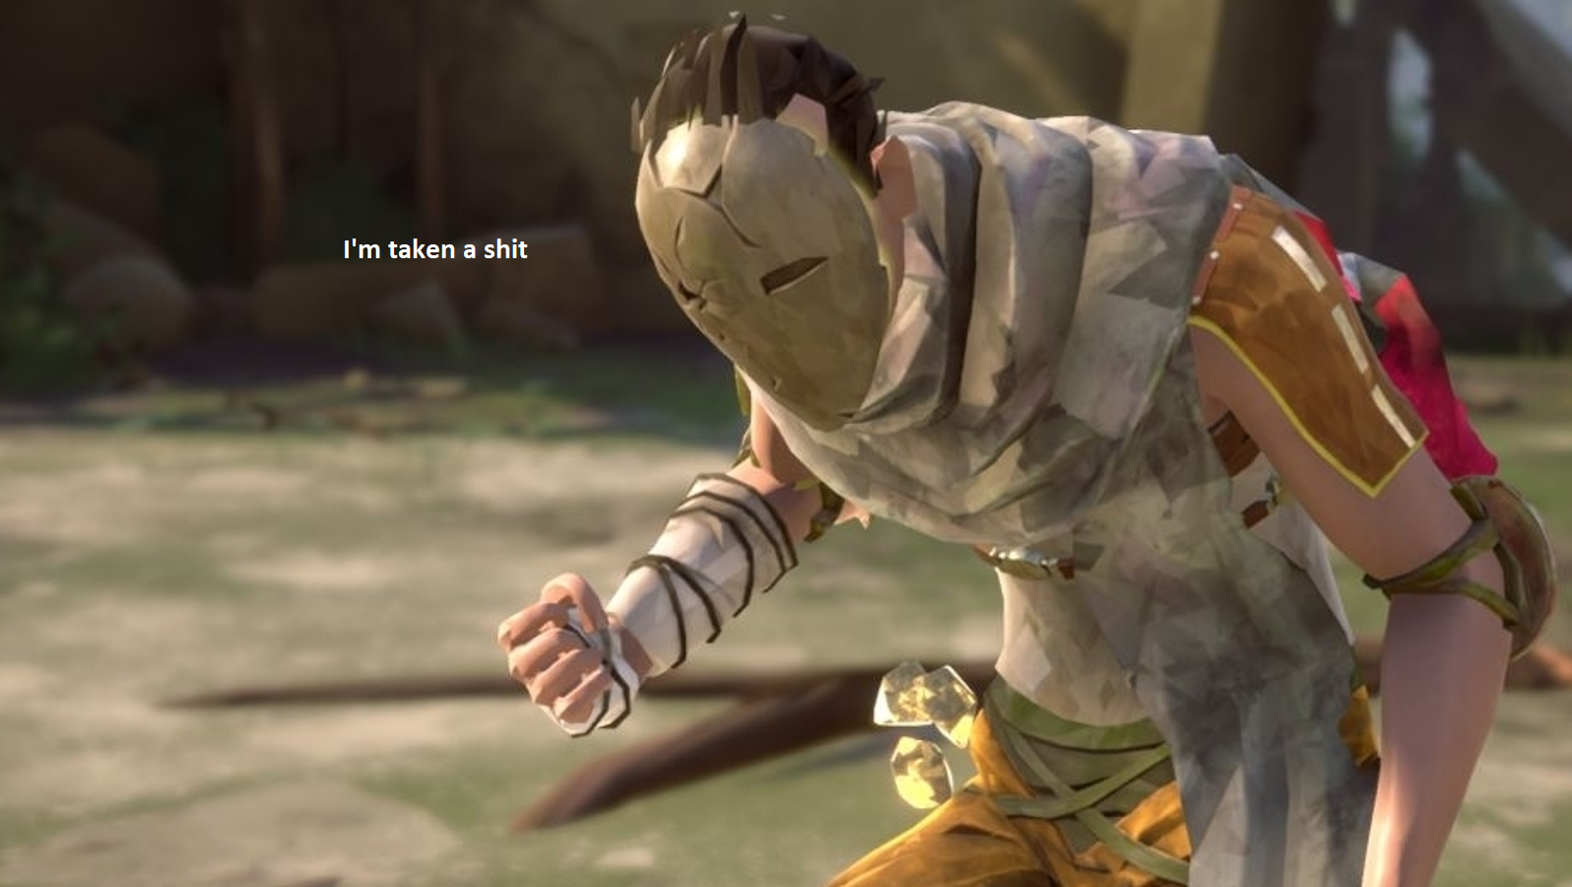
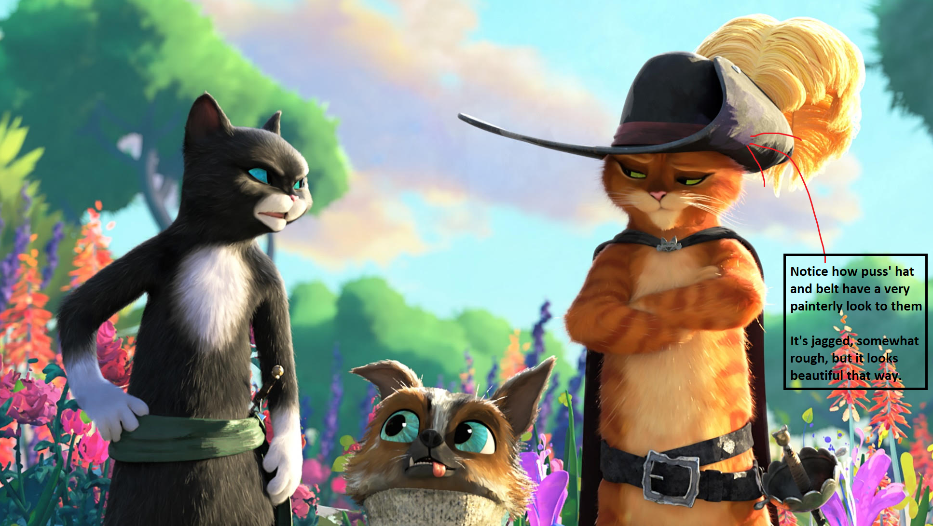
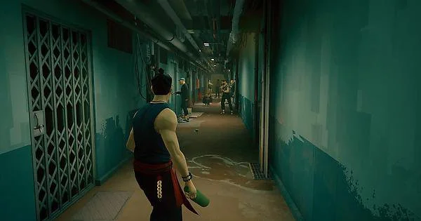
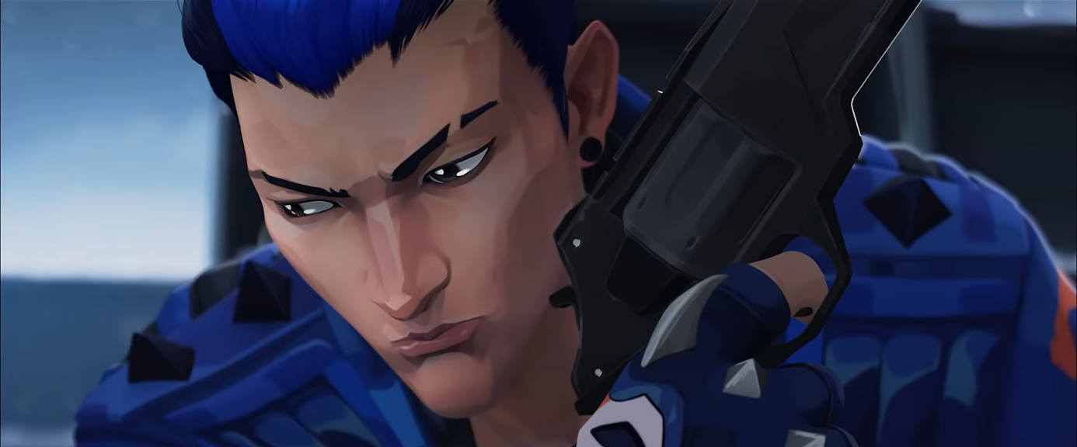

3.2 Visual feedback and visual effects
Visual feedback is important as it necessitates and elevates the current action taking place within the game-world. A good way to add some extra “oomph” to a scene/action is proper visual feedback.

CHARACTERS and anything of mild interest have a slight fresnel effect applied, which can look like rim lighting, but it makes it stand out organically while maintaining the stylised look.

An example is provided above with the puss in boots stuff, and also below.

4.1 Levels
Obviously a game needs an area to be played in, so let’s get some of those down first.

Given that our heroes are ASCENDING a tower, it would make sense to have the characters go through chambers, and after the boss fight, there’s another chamber with a staircase/stairwell, leading to the next section.

The level areas are basically set-rooms that connect to each other, think of it like a tileset of rooms from Warframe or Binding of Isaac in terms of creation.
Obviously each room would be different from the last and this allows for greater replayability in the game, as opposed to having the same levels through and through.
But, given that it’s a set tile, it still allows for mastery of that specific tile on each repeated run, allowing for organic player progression (The player gets better themselves)

Note: There are two types of player progression in terms of them getting better at the game.
Organic Progression : The player gets better themselves ( seen in games like Counter Strike, Modern Warfare etc.)
Artificial Progression : The player gets better because their stats become bigger

An example of tileset rooms and levels looks kinda like this:

Binding of Isaac
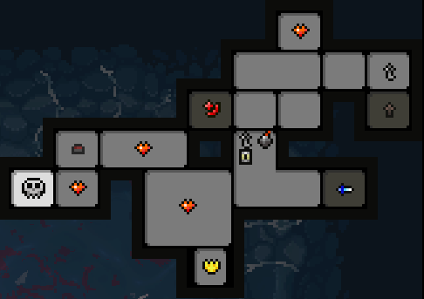
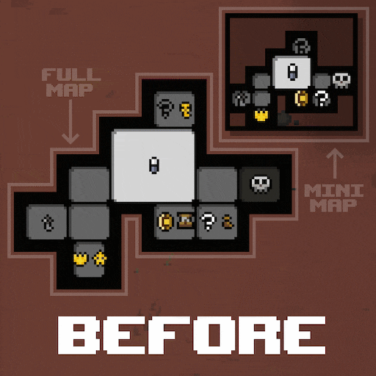
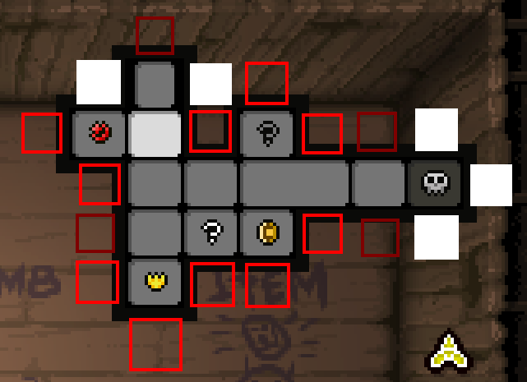
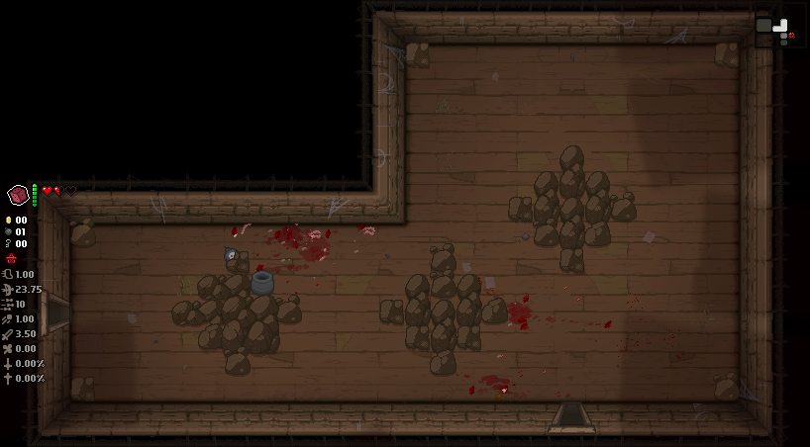
Okay, everyone understands that? k let’s move on.

4.2 List of Levels
This section consists entirely of the list of areas. They will be expanded upon in 4.3 and onwards of the document. Firstly, let’s try and get the first stage and first character, Wuxia done.

After each main “combat” portion, they enter the next hub section. There is of course the starting hub section.

- The Ruined Kingdom (Concept is just a simple start dungeon, think of the fallen forts from Stoneshard in terms of design and aesthetic)
- Rain fallen-hub, blue filter would help emphasise the “coldness” of the area.
- Rainy weather and japanese, idk but I’ll have to look it up to get an idea of what I want later
- Ice and snow-fallen hub
- Icy cave like level design
- fire-like, kind of like the base of an inactive volcano. Granite and what not surrounding the area with open-air amenities. Also a hub area (Marching fire for honor moment)
- fire-based level, structures on the verge of burning down and crumbling, yet still holding on. Either burning structures or active volcano setting (similar to the hi-fi rush RnD level)
- Final stage is set in a dimension-teared room, the rooms are a mish mash of the previous stages’ aesthetics, but all with a ferrofluid-like drip at the seams. Think of Yoru’s visual effects from Valorant. Emphasis on ferrofluid motions. No hub. Just straight to the next fight.

7.1 Progression
As mentioned before, the game features rogue-lite progression, which increases health and also gives access to more moves with each subsequent run, as the player unlocks more and more upgrades.

There are three main methods of progression in Forgotten Paragons

-Player progression via purchasable upgrades using SOULS (Permanent)
-Player progression mid-run (not-permanent and are removed at the start of a new run) (things like money for a mid-run shop, etc.)
-Permanent unlockable items.

7.2 Souls

The game is centred around releasing the lost souls of the tower, this is done by brutalising them and beating them up of course!

When enemies perish, they drop souls, souls are used to upgrade the four heroes. Enhancing their general combat capabilities (health, stamina, focus/adrenaline) or giving them access to new abilities (All characters have character-specific moves, movesets and attributes).

Tougher enemies drop more souls etc. you get the point, it’s just darkness from Hades.

It would look very ephemeral and smokey, kind of like the vfx that plays when you perish in Dark Souls, where your character sort of dissipates and scatters like dust upon death.

An example of how it would look like is shown below
(the doc ends here sorry)

